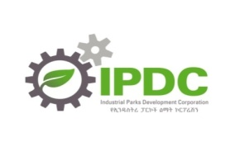

Striving for eco-Industrial parks excellence!

